# AMERICAN YOUTH FOOTBALL

## Volunteer Forms

### REQUIRED FOR REGIONAL AND NATIONAL PARTICIPATION

Volunteer forms must be presented for compliance verification prior to any team participation in any American Youth Football, Inc., American Youth Cheer dba, Regional, National sanctioned event.

All Coach / Volunteers must complete the following paperwork in order to be allowed to participate in any American Youth Football, Inc., American Youth Cheer dba, Regional, National sanctioned event.

**Image Release ADULT**

**Waiver Release of Liability ADULT**

NOTE: Coach and the Team designated Mandatory Play Monitor, Team Photographer, must have these forms completed or they will not be allowed on the field.

Any form / document used for your local Association / Conference must be reviewed by your local council to insure it's compliance with all of your state and local statutes. AYF makes no representation or warrantee that any of these conditions have been met.

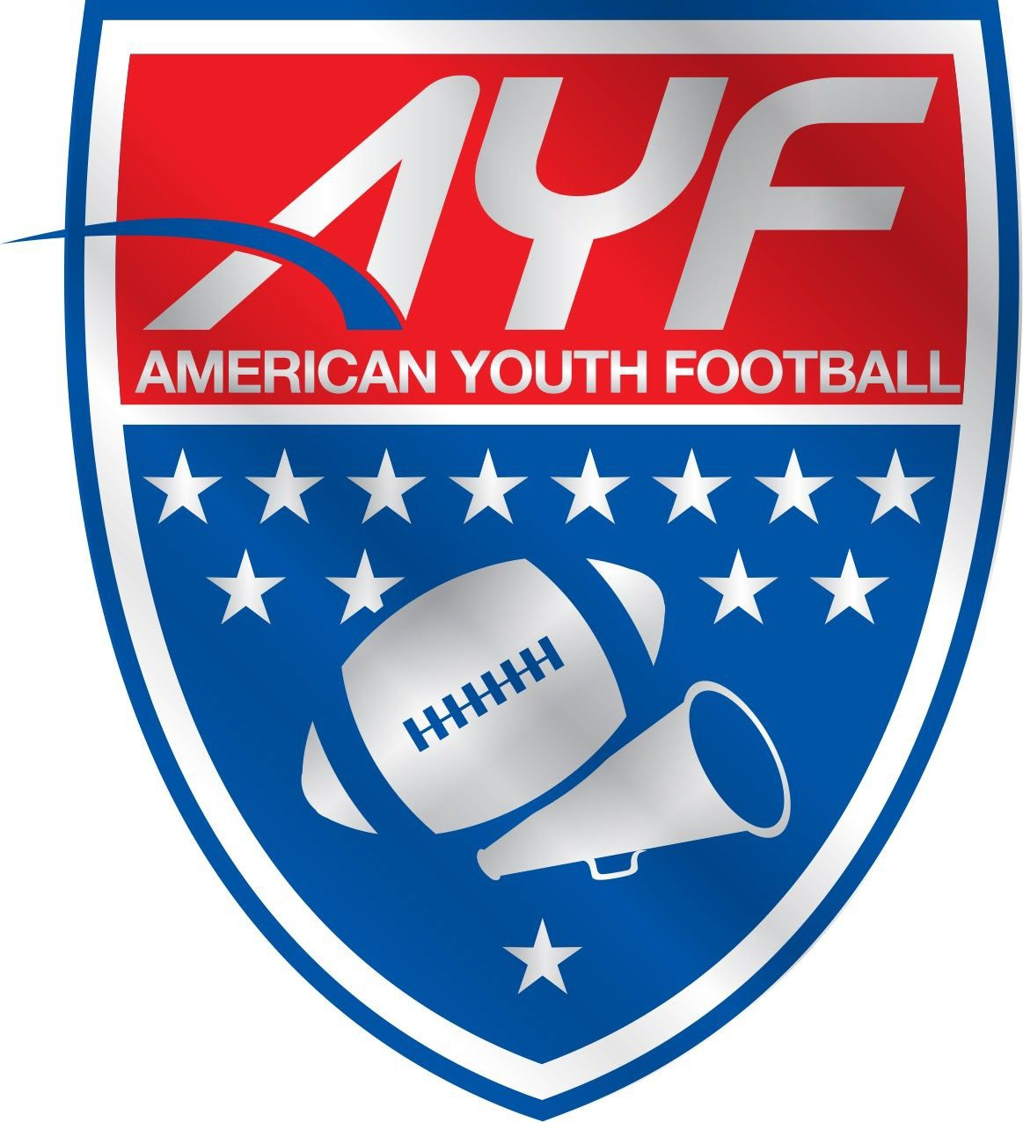AMERICAN YOUTH FOOTBALL

## Amateur Athletic Waiver and Release of Liability - Adult

### ASSOCIATION NAME - Seymour AYFC

**READ BEFORE SIGNING**

IN CONSIDERATION OF being allowed to participate in any way in the American Youth Football (AYF) or American Youth Cheer Regional/National Championships, football and or cheer programs of

Seymour Tigers AYF

, the Local Organization, which is a legally distinct and organization not operated or controlled by American Youth Football, despite its membership with American Youth Football, Inc. acknowledges and agrees that:

1. The risks of injury and illness (ex: communicable diseases such as MRSA, influenza, and COVID-19) from the activities involved in this program are significant, including the potential for permanent paralysis and death, and while particular rules, equipment, and personal discipline may reduce these risks, the risks of serious injury and illness do exist; and,
2. I KNOWINGLY AND FREELY ASSUME ALL SUCH RISKS, both known and unknown, EVEN IF ARISING FROM THE

NEGLIGENCE OF THE RELEASEES or others, and assume full responsibility for my participation; and,

1. I willingly agree to comply with the stated and customary terms and conditions for participation. If, however, I observe any unusual significant hazard during my presence or participation, I will remove myself from participation and bring such to the attention of the nearest official immediately; and,
2. I, for myself and on behalf of my heirs, assigns, personal representatives and next of kin, HEREBY RELEASE AND HOLD HARMLESS American Youth Football, Inc. their officers, officials, agents, and/or employees, other participants, sponsoring agencies, sponsors, advertisers, and if applicable, owners and lessors of premises used to conduct the event (“RELEASEES”), WITH RESPECT TO ANY AND ALL INJURY, ILLNESS, DISABILITY, DEATH, or loss or damage to

person or property, WHETHER ARISING FROM THE NEGLIGENCE OF THE RELEASEES OR OTHERWISE, to the fullest extent permitted by law.

I HAVE READ THIS RELEASE OF LIABILITY AND ASSUMPTION OF RISK AGREEMENT, FULLY UNDERSTAND ITS TERMS, UNDERSTAND THAT I HAVE GIVEN UP SUBSTANTIAL RIGHTS BY SIGNING IT, AND SIGN IT FREELY AND VOLUNTARILY WITHOUT ANY INDUCEMENT.

Print Name of Participant:

Participant’s Signature: Date Signed:

#### FOR PARTICIPANTS OF MINORITY AGE (UNDER AGE 18 AT THE TIME OF REGISTRATION)

This is to certify that I, as parent/guardian with legal responsibility for this participant, do consent and agree to his/her release as provided above of all the Releasees, and for myself, my heirs, assigns, and next of kin, I release and agree to indemnify and hold harmless the Releasees from any and all liabilities incident to my minor child/ward s involvement or participation in these programs as provided above, EVEN IF ARISING FROM THEIR NEGLIGENCE, to the fullest extent permitted by law.

Print Name of Parent/Guardian:

Parent/Guardian Signature: Date Signed:

Emergency Phone Number: ( ) -

**NOTE:** This form as with any and all forms used by your Association should be reviewed by your local counsel for compliance with any state or local statutes. This form should be kept on file for a minimum of 7 years, longer in the event of an injury. Please confer with your local attorney for advice as to the appropriate maintenance and storage term for this and all such forms.

# AMERICAN YOUTH FOOTBALL

## Image Release - ADULT

### ASSOCIATION NAME – Seymour AYFC

**READ BEFORE SIGNING**

I (insert name) ,in consideration of

being allowed to participate in any way, in the American Youth Football, Inc. ("AYF") (dba American Youth Football and American Youth Cheer,) national championships and any other official AYF events and activities, do hereby grant to American Youth Football Inc., the unrestricted right and permission, free from approval or review, to copyright and/or use my likeness in any and all media now or hereafter known, including but not limited to, pictures and videos of which I may be included intact or in part for promotion or other commercial use.

Print Name:

Signature: Date Signed:

#### Seymour Tigers Youth Football and Cheer Coach’s Application and Team Mom Application

* Football Assistant Coach
* Cheer Assistant Coach
* Team Mom – Football
* Team Mom - Cheer

Full Name Preferred Team Address City, State and Zip Code Telephone and email address

* I understand that by submitting this application I am giving permission for Seymour AYFC to run a background check. A background check is done to ensure safety to our athletes.
* To proceed with the required background check, a valid driver’s license and social security number must be submitted to [seymourayfc@yahoo.com](mailto:seymourayfc@yahoo.com) within 48 hours of initial selection prior to final assignment as head coach

All information gathered and discovered in background checks are confidential

* I understand that by submitting an application that I am not guaranteed a coaching position
* I understand that the organization can deny an application at the discretion of the Executive Board. I waive any liability against Seymour Tigers Youth Football and Cheer
* Uncompleted applications will not be accepted
* All applications are to be emailed to [seymourayfc@yahoo.com](mailto:seymourayfc@yahoo.com) prior to the 12am deadline of specified date
* Each Application is valid for the current season and will not be carried into upcoming seasons

Coaches are required to complete all mandatory training per AYF Rules and Regulations.

Regardless of qualifications, a candidate cannot be selected for any coaching without completing an application form, passing the mandatory background check, completing AYF/AYC certifications, signing the Code of Conduct, and approval by the Executive Board.

Applications are valid until December 31st of current year. A new application needs to be completed every season.

## Assistant Coach Application/Team Mom:

**The Head Coach holds ultimate responsibility of their respective team. The roles of Assistant Coach and Team Mom are to support the Head Coach in carrying out team operations, communication, and ensuring a positive experience for all athletes.**

* The Role requires regular schedule adherence; including but not limited to evenings and weekends. Are you able to commit to this availability? ________________ (Initials)
* Practice must adhere to the designated schedule. If practice times need to be adjusted, the football commissioner or cheer coordinator must be notified 48 hours in advance ________ (Initials)
* If practices need to be rescheduled or moved, the football commissioner or cheer coordinator need to notified 24 hours prior to ensure proper medical coverage is scheduled ________ (Initials)
* Adhere to all AYF required training and have completed within AYF/SYFC timeframe (Initials)
* Coaches/Team Moms are required to volunteer for at least one home game not including one’s own team ____ (Initials)
* Coaches/Team Moms are required to participate and support league fundraising events _______ (Initials)
* Coaches/Team Mom can be removed by the Executive Board ___________(Initials)
* As a competitive league, both football and cheer coaches and team parents are expected to travel with their teams to championship games, tournaments, competitions and sideline cheering as teams progress throughout the season _______________(Initials)
* Coaches may not sit out any participant without filling out and having the parent and coordinator sign the appropriate paperwork. All discipline will be discussed with the appropriate coordinator. (Initials)
* Non-compliance with these conditions and the Seymour AYF Code of Conduct may lead to disqualification and removal by the Executive Board from current and future seasons. _______ (Initials)

Coaching or Volunteering Experience

How will you coordinate with the Head Coach, other coaches, athletes and parents to support the team environment?

Signature and Date

**2025 Seymour Tigers Youth Football and Cheerleading Coach’s Code of Conduct**

Seymour Tigers Youth Football and Cheerleading believes that: participation in any sports program plays an important role in promoting the physical, social, and emotional development of our youth. It is essential for Seymour AYFC to provide a positive and enjoyable learning experience for youth, teaching sportsmanship, fair play, integrity, honor, respect, loyalty, personal courage, and dedication through the game of football. Furthermore, parents, coaches, spectators, and officials involved in youth sports events should be models of such statements and should lead by example by demonstrating fairness, respect, and self-control. Seymour AYFC has established this Code of Conduct and requires that you commit to be responsible for your words and actions while attending, or participating in all events and that you conform your behavior to the following Code of Conduct:

**Coach’s Code of Conduct With regard to my players:**

1. I believe that my role as a coach is to contribute to the overall success, physical, and athletic growth of the player through participation in football.

2. I will provide organized team practices each week that will provide for the development of both team and individual skills and will make full effort to provide practices that are both fun

3. I will endeavor to be a good instructor and a positive role model for my players.

4. I believe that the score of a game comes second to the safety and welfare of all my players.

5. I will endeavor to put winning in its proper perspective.

6. I am responsible for understanding and competing within the letter and the spirit of the rules set forth by Seymour AYFC and the leagues it is associated with.

7. I will teach my players to understand and play within the letter and spirit of the rules, as well.

**Regarding opposing teams:**

1. I believe that the way my team conducts itself has an influence, for better or worse, on those we compete against.

2. I will endeavor to make my team a positive role model.

3. I will not coach, nor allow my players to play, with intent to cause injury to opposing players.

4. Neither I nor my players and spectators will display hostile behavior towards opposing players.

5. Neither I nor my players and spectators will speak in a negative manner toward any member or spectator from the opposing team.

6. I will emphasize winning without boasting and losing without bitterness.

**Regarding Referees:**

1. I believe that referees, just as coaches and players, are attempting to do their best.

2. I will instill in my players and spectators a respect for that fact.

3. I understand that my attitude can influence my players and spectators.

4. I will always display a controlled and undemonstrative attitude toward Referees.

5. Neither I nor my players and spectators will address a Referee before, during or after the game in a demeaning fashion.

6. I understand that only Head Coaches can address referees during a game.

**Seymour AYFC Expectations:**

1. We expect you to create a FUN & SAFE environment for the kids

2. We expect the kids to work hard and get better every day – they are having fun & working hard, we have accomplished our goal

3. We expect coaches to remain positive; it’s not all about winning

4. We expect constant communication with your parents – emails, website, phone calls, etc.

5. We expect teamwork

**Other Items:**

1. I will not use tobacco, drugs or alcohol while at a youth sports event and will not attend, coach, officiate or participate in a youth sports event while under the influence of drugs or alcohol.

2. I will not engage in the use of profanity

3. I will not tolerate behavior that endangers the health or well-being of a child.

Coaches are responsible for the conduct of their players and the spectators on their side of the field, specifically as it relates to the referees, coaches, players and spectators on the other team. Verbal and/or physical abuse will not be tolerated. Any coach showing this type of behavior shall be subject to disciplinary action as dictated by and at the discretion of Seymour AYFC and its Board of Directors. I further understand that my failure to abide by this code of conduct may result in disciplinary action by Seymour AYFC which may include but is not limited to game suspension and/or my rights to participate as a coach for Seymour Youth Football and Cheerleading

Name of Coach______________________________________________________________

Signed ___________________________________________________ Date______________

#### Social Media Policy

The use of social media can be problematic when players, cheerleaders, coaches, or administrators use social media to berate, incite, insult, harass, etc. other players, cheerleaders, coaches, administrators, teams, or Associations by publishing, posting, or distributing inappropriate content including racially charged remarks. As individuals and as an organization, we need to have a zero-tolerance policy for this behavior. As such, any player, cheerleader, coach, or administrator publishing, posting, distributing, etc. inappropriate content as described above on social media will be suspended for the remainder of the current season, including any post season play with no right for appeal.

I have read the **Social Media Policy** and understand what is expected.

Print Name Signature Date